BASH SCRIPTING

1.Create a bash script tocheck if a directory is available or not.

Step 1: Create the script file
vim check_dir.bash

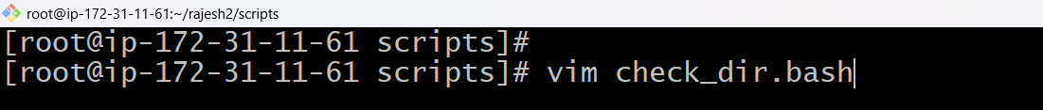

Press “I” + enter
#!/bin/bash

DIR="/home/ec2-user/mydirectory"

if [ -d "$DIR" ]; then
echo "Directory exists."
else
echo "Directory does not exist."
Fi
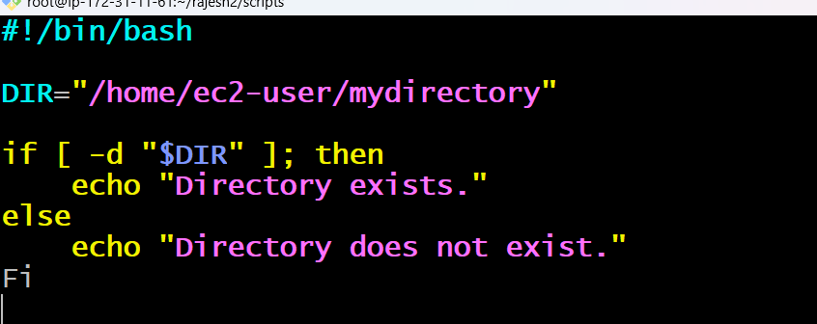
Save:
- Esc :wq Enter
Check the Information:
Cat check_dir.bash
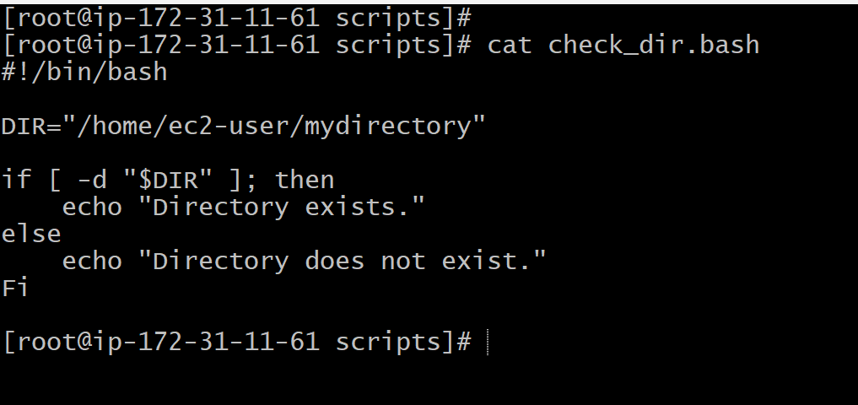
Step 2: Give it execute permission
chmod +x check_dir.bash
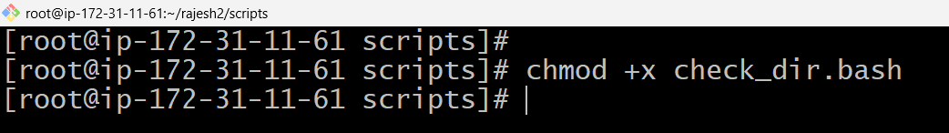.

Step 3: Run the script
./check_dir.bash /home/user/Documents

Step 4: Read the result

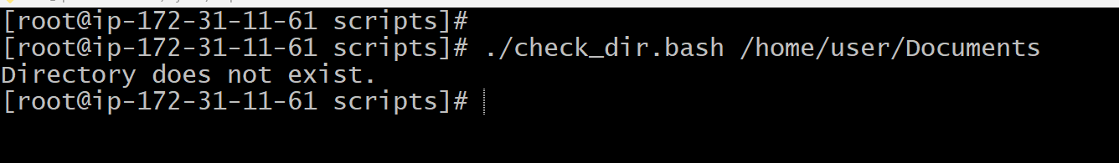Quick Summary
1. Create file + Write script → 3. chmod +x → 4. Run with a path → 5. Check output.
2. Create a bash script to create multiple files.

Step 1: Create the script file
vim create_files.bash

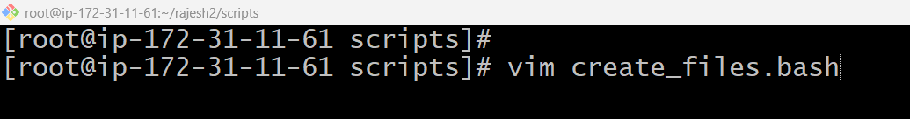
Press "I" + enter

#!/bin/bash
FILES=("file1.txt" "file2.txt" "file3.txt")

for f in "${FILES[@]}"; do
touch "$f"
echo "Created: $f"
done
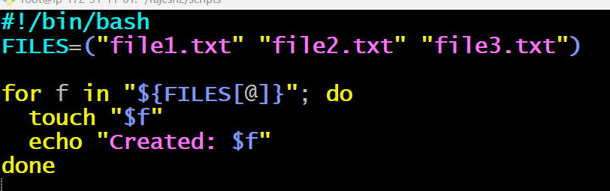

Save:
- Esc :wq Enter

Check the Information:
cat create_files.bash
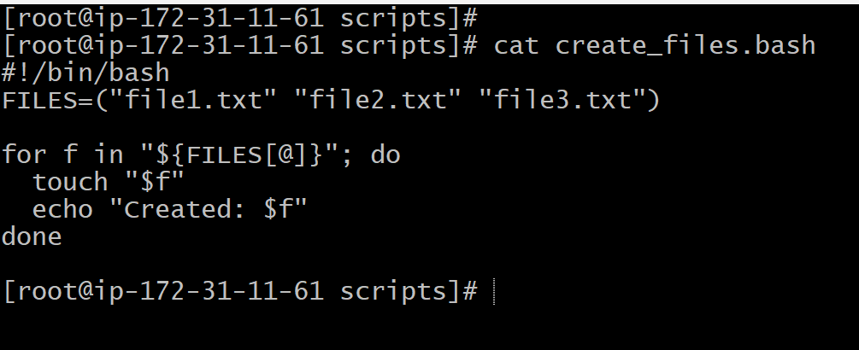

Step 2: Give it execute permission
chmod +x create_files.bash

Step 3: Run the script
./create_files.bash

Step 4: Read the result

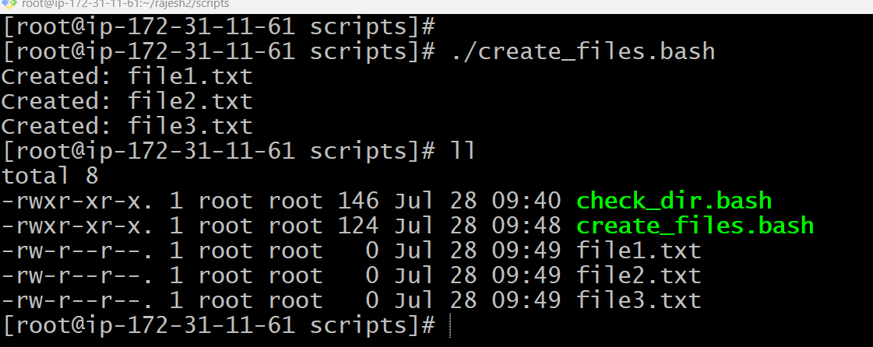
Quick Summary
1. Create file → 2. Write script → 3. chmod +x → 4. Run the script → 5. Check output (files created).

3. Create a bash script to take a backup of a directory.

Step 1: Create the script file
vim backup_dir.bash
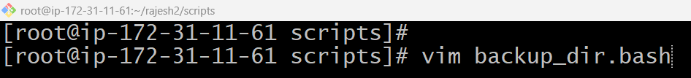

Press "I" + enter

#!/bin/bash
SRC_DIR="/home/ec2-user/mydirectory"
BACKUP_DIR="/home/ec2-user/backups"
DATE=$(date +%Y-%m-%d_%H-%M-%S)

mkdir -p "$BACKUP_DIR"

if [ -d "$SRC_DIR" ]; then
tar -czf "$BACKUP_DIR/backup_$DATE.tar.gz" "$SRC_DIR"
echo "Backup completed: backup_$DATE.tar.gz"
else
echo "Source directory does not exist."
fi

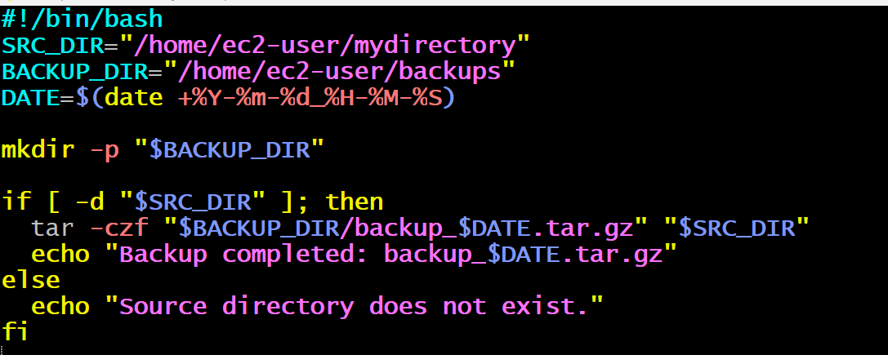
Save:
- Esc :wq Enter

Check the Information:
cat backup_dir.bash
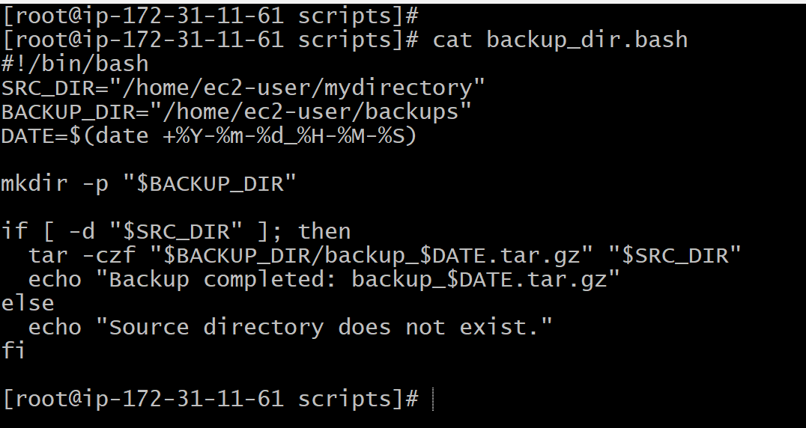

Step 2: Give it execute permission
chmod +x backup_dir.bash
Step 3: Run the script
./backup_dir.bash
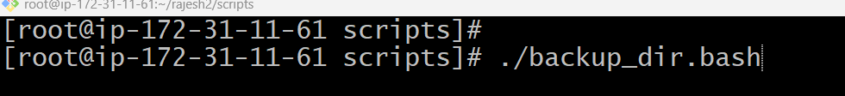

Step 4: Read the result

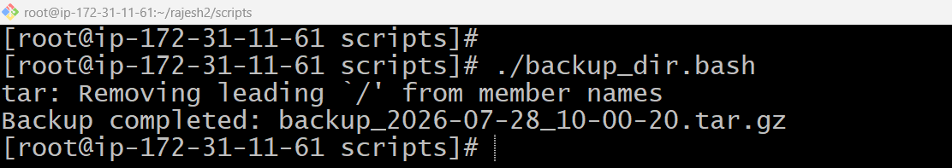
Quick Summary
1. Create file → 2. Write script → 3. chmod +x → 4. Run the script → 5. Check output (backup .tar.gz created).

4.Create a bash script to install Nginx on an EC2 server.
Step 1: Create the script file
vim install_nginx.bash
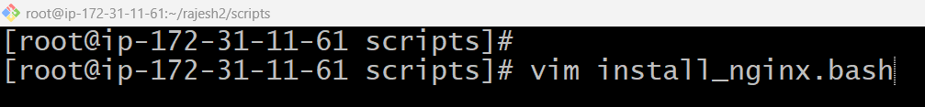

Press "I" + enter

#!/bin/bash

echo "Updating packages..."
sudo yum update -y

echo "Installing Nginx..."
sudo dnf install nginx -y
echo "Starting Nginx service..."
sudo systemctl start nginx
sudo systemctl enable nginx
sudo systemctl status nginx

echo "Nginx installation completed."

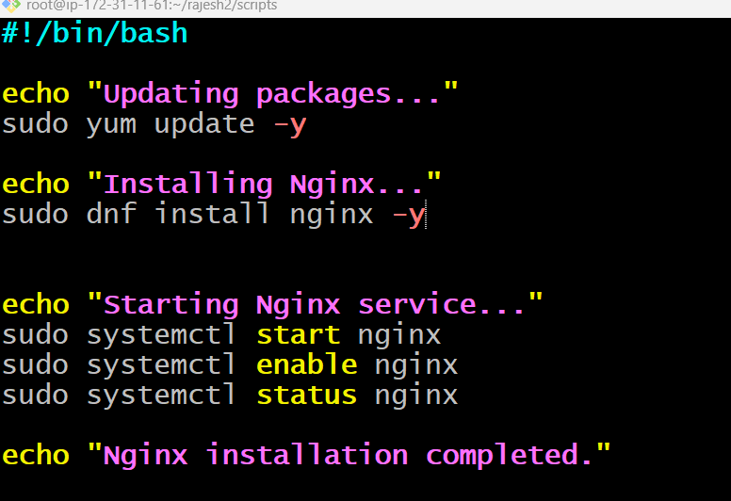
Save:
- Esc :wq Enter

Check the Information:
cat install_nginx.bash
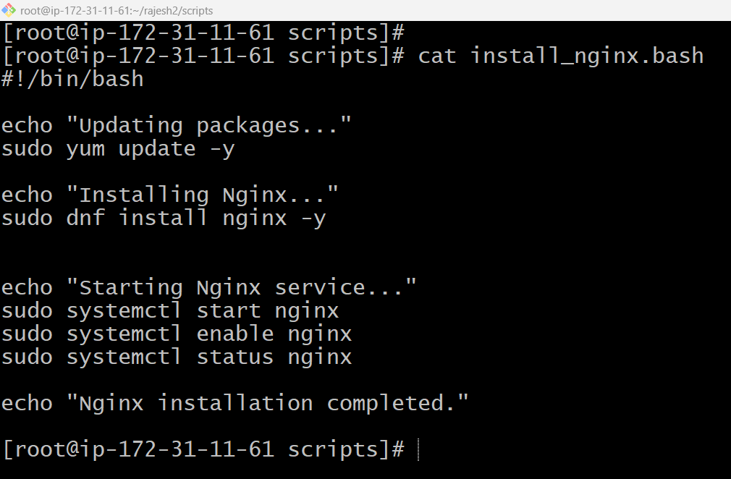

Step 2: Give it execute permission
chmod +x install_nginx.bash
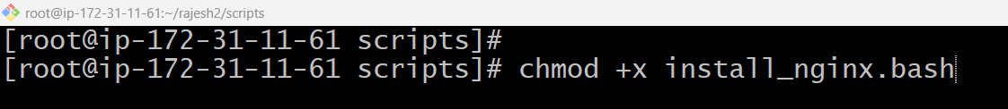

Step 3: Run the script
./install_nginx.bash
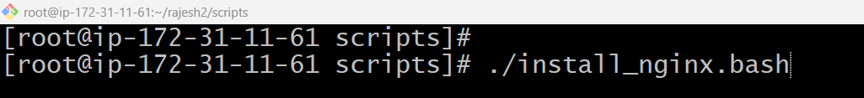

Step 4: Read the result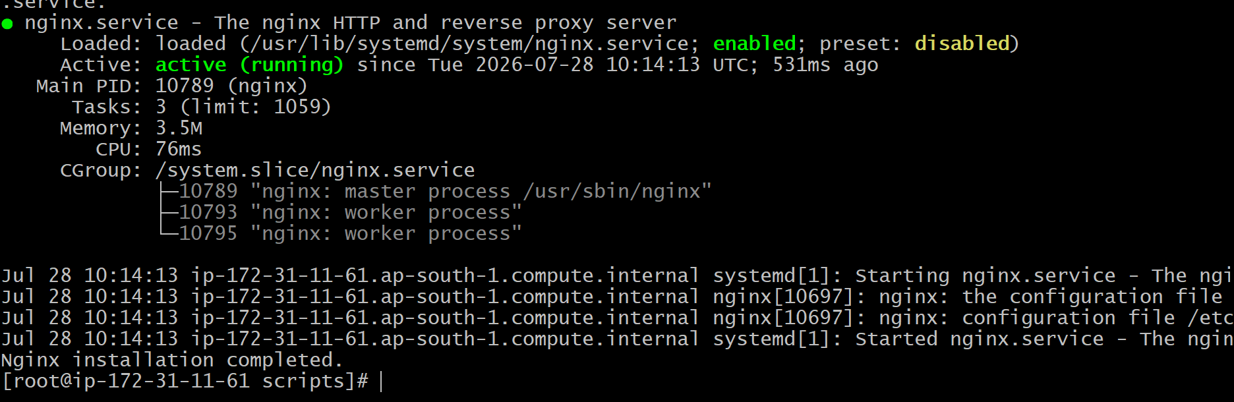

Quick Summary
1. Create file → 2. Write script → 3. chmod +x → 4. Run the script → 5. Check output (Nginx active and serving on port 80).
5. Create a bash script to install Apache Tomcat on an EC2 server.
Step 1: Create the script file
vim install_tomcat.bash
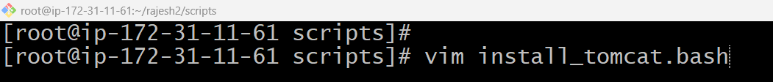

Press "I" + enter

#!/bin/bash

TOMCAT_VERSION=10.1.30
INSTALL_DIR="/opt/tomcat"

echo "Updating packages..."
sudo yum update -y

echo "Installing Java..."
sudo yum install java-17-amazon-corretto -y

echo "Downloading Tomcat $TOMCAT_VERSION..."
cd /opt
sudo wget https://downloads.apache.org/tomcat/tomcat-10/v$TOMCAT_VERSION/bin/apache-tomcat-$TOMCAT_VERSION.tar.gz

echo "Extracting Tomcat..."
sudo tar -xzf apache-tomcat-$TOMCAT_VERSION.tar.gz
sudo mv apache-tomcat-$TOMCAT_VERSION "$INSTALL_DIR"

echo "Starting Tomcat..."
sudo chmod +x "$INSTALL_DIR"/bin/*.sh
sudo "$INSTALL_DIR"/bin/startup.sh

echo "Tomcat installation completed."

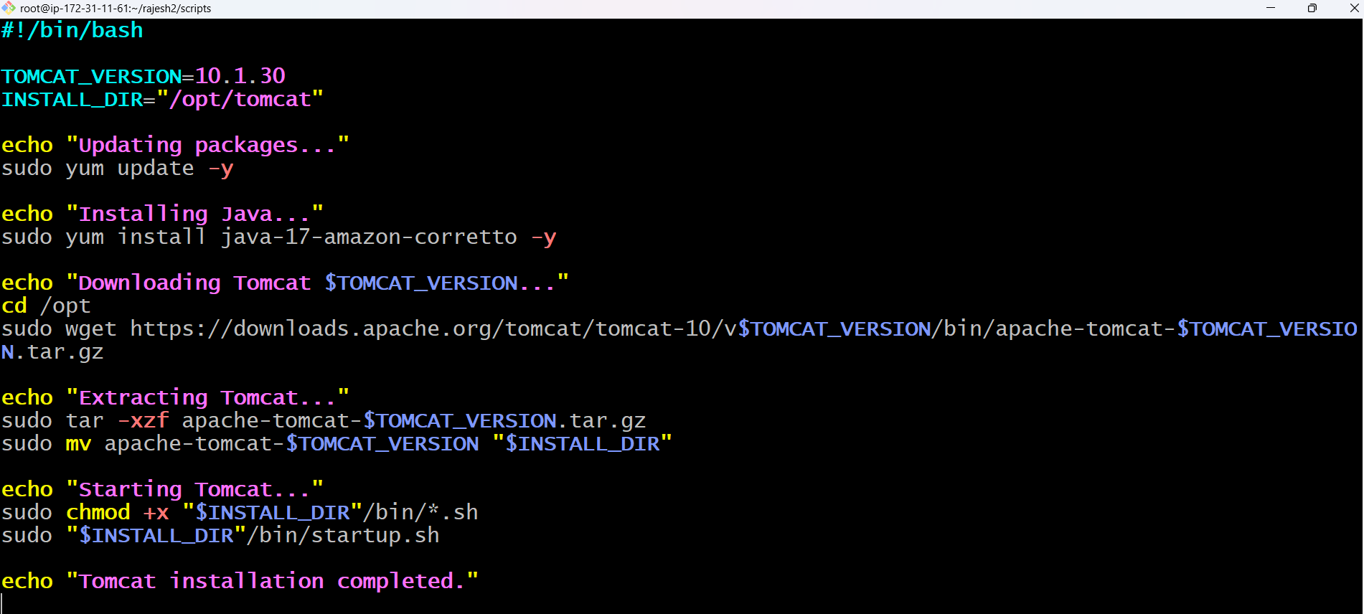
Save:
- Esc :wq Enter

Check the Information:
cat install_tomcat.bash
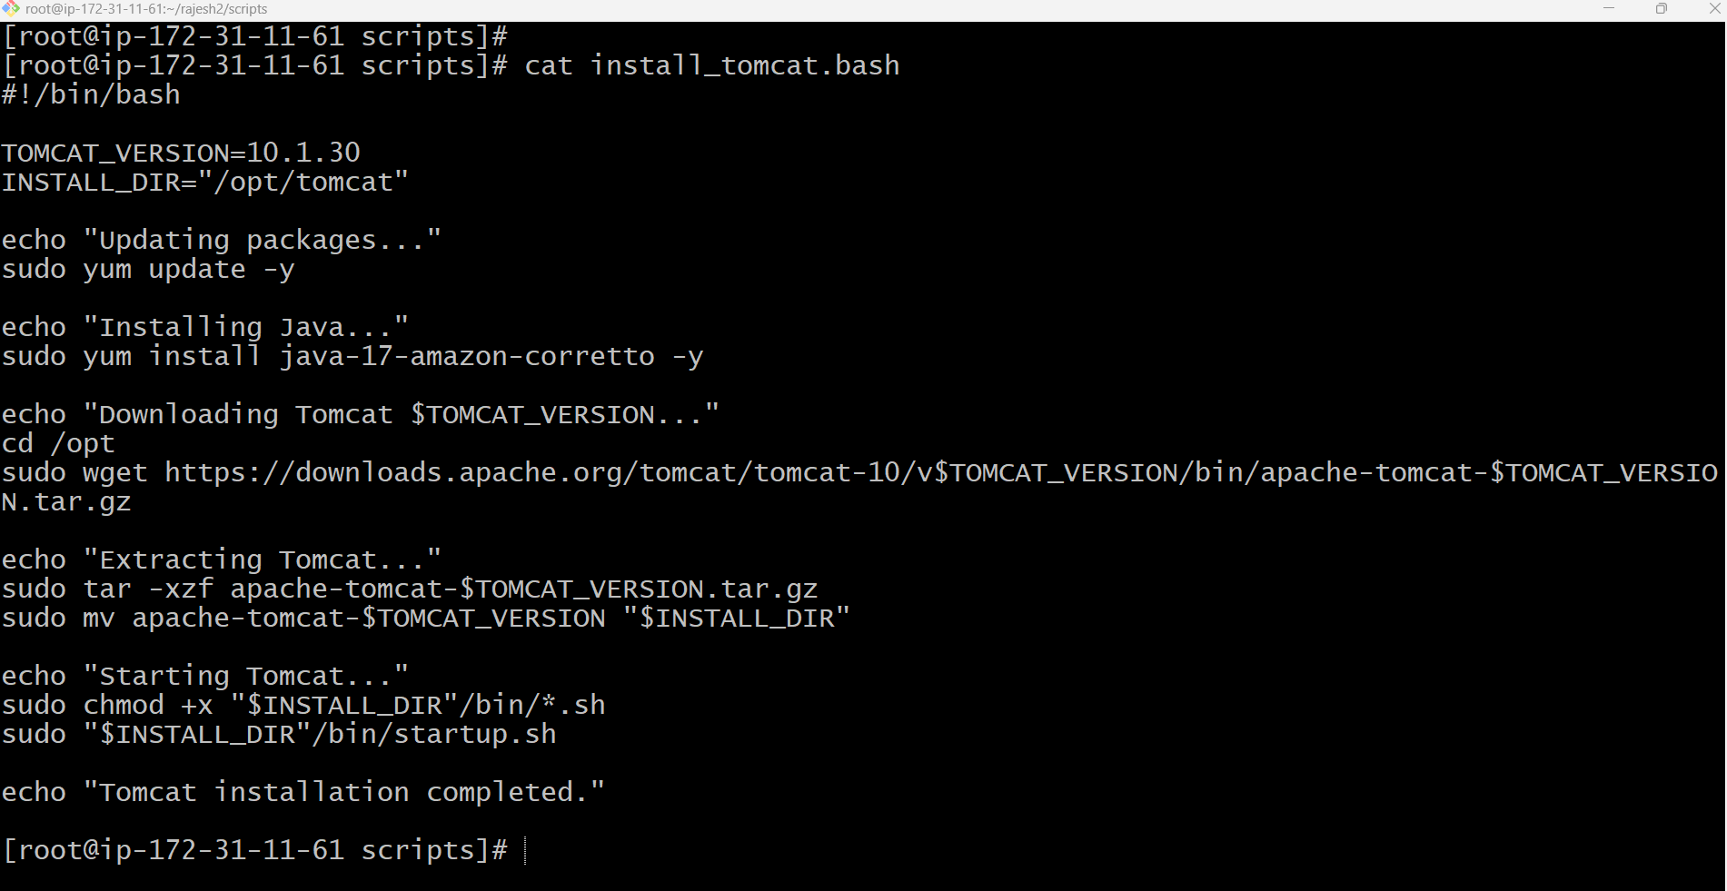

Step 2: Give it execute permission
chmod +x install_tomcat.bash
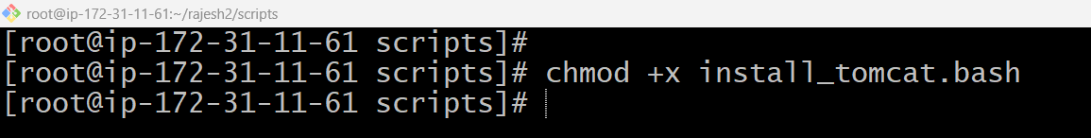

Step 3: Run the script
./install_tomcat.bash

Step 4: Read the result

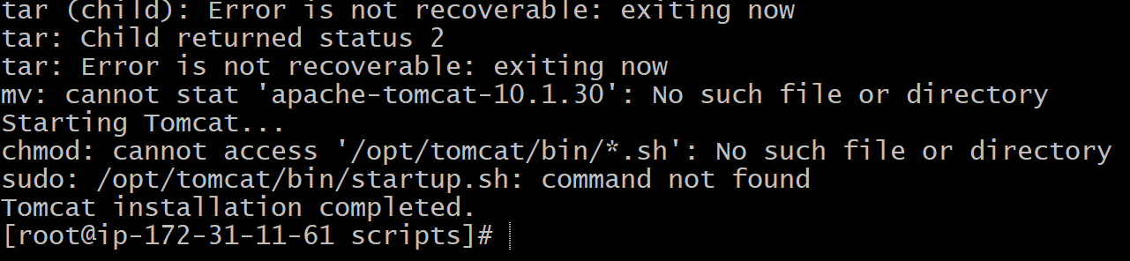
Quick Summary
1. Create file → 2. Write script → 3. chmod +x → 4. Run the script → 5. Check output (Tomcat running on port 8080).
6.Create a bash script to check if the Nginx service is running, if not running then start the service.
Step 1: Create the script file
vim check_nginx.bash

Press "I" + enter

#!/bin/bash
SERVICE="nginx"

if systemctl is-active --quiet "$SERVICE"; then
echo "$SERVICE is already running."

elif systemctl is-enabled --quiet "$SERVICE"; then
echo "$SERVICE is stopped but enabled. Starting it now..."
sudo systemctl start "$SERVICE"

else
echo "$SERVICE is stopped and not enabled."
sudo systemctl start "$SERVICE"
fi

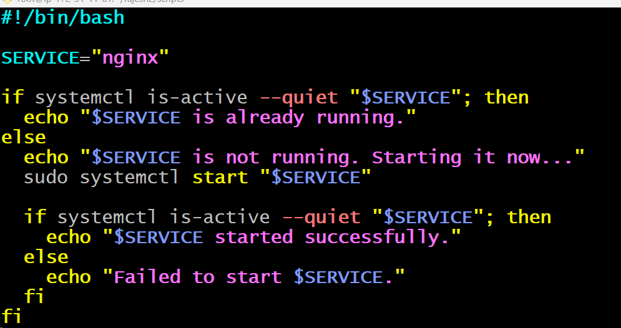
Save:
- Esc :wq Enter

Check the Information:
cat check_nginx.bash
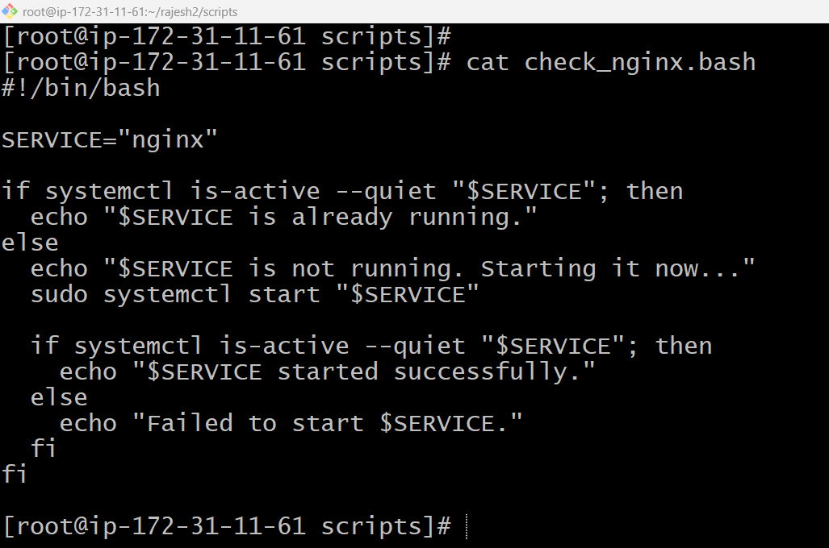

Step 2: Give it execute permission
chmod +x check_nginx.bash

Step 3: Run the script
./check_nginx.bash
Step 4: Read the result

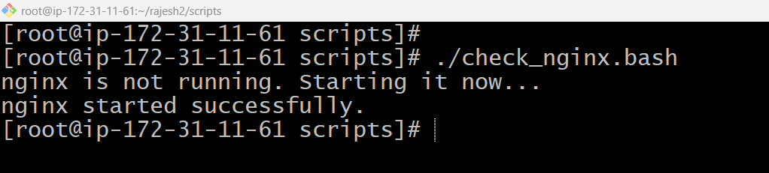
Quick Summary
1. Create file → 2. Write script → 3. chmod +x → 4. Run the script → 5. Check output (Nginx checked and started if it was down).
7.Create a bash script for a calculator.
Step 1: Create the script file
vim calculator.bash
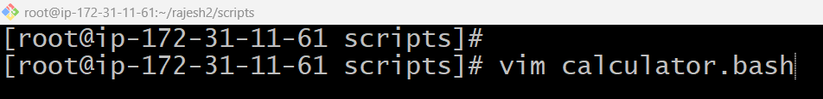

Press "I" + enter

#!/bin/bash

echo "Enter first number:"
read num1

echo "Enter second number:"
read num2

echo "Choose an operation: + - \* /"
read op

case "$op" in
"+") result=$(echo "$num1 + $num2" | bc) ;;
"-") result=$(echo "$num1 - $num2" | bc) ;;
"*") result=$(echo "$num1 * $num2" | bc) ;;
"/")
if [ "$num2" -eq 0 ] 2>/dev/null; then
echo "Error: Division by zero."
exit 1
fi
result=$(echo "scale=2; $num1 / $num2" | bc) ;;
*)
echo "Invalid operation."
exit 1 ;;
esac

echo "Result: $result"

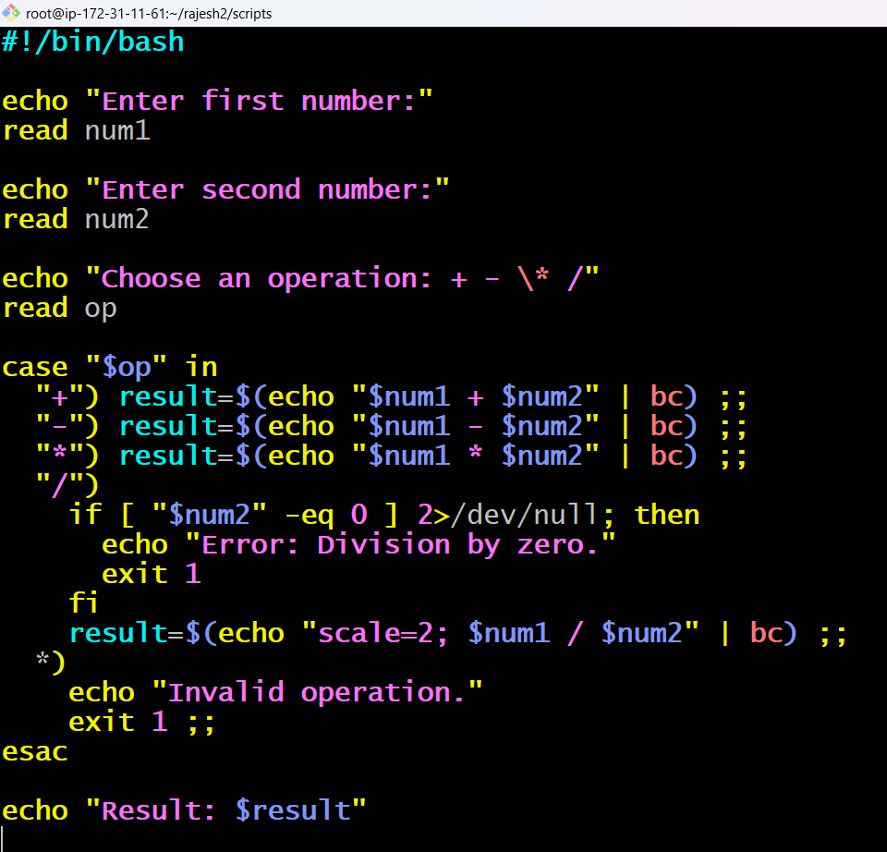
Save:
- Esc :wq Enter

Check the Information:
cat calculator.bash

Step 2: Give it execute permission
chmod +x calculator.bash
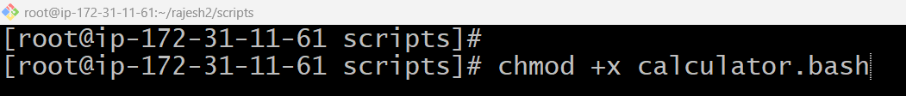

Step 3: Run the script
./calculator.bash
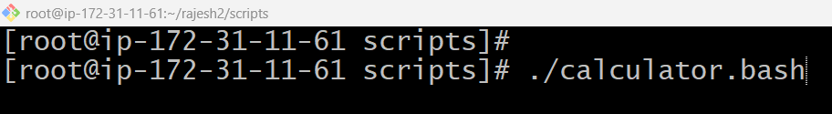
Step 4: Read the result

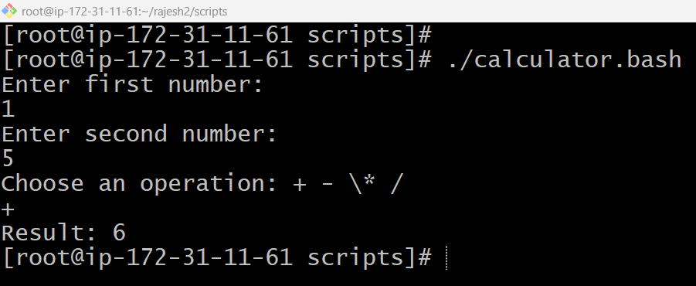
Quick Summary
1. Create file → 2. Write script → 3. chmod +x → 4. Run the script → 5. Check output (calculation result or error handled).

8. Create a bash script to check if a directory exists, if not then create the directory.
Step 1: Create the script file
vim create_if_missing.bash

Press "I" + enter

#!/bin/bash

DIR="/home/ec2-user/mydirectory"

if [ -d "$DIR" ]; then
echo "Directory already exists: $DIR"
else
echo "Directory does not exist. Creating it now..."
mkdir -p "$DIR"

if [ -d "$DIR" ]; then
echo "Directory created successfully: $DIR"
else
echo "Failed to create directory."
fi
fi

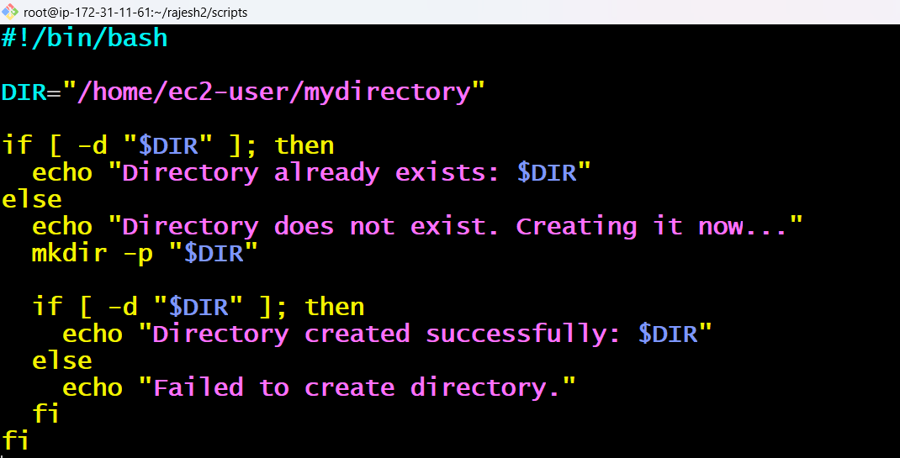
Save:
- Esc :wq Enter

Check the Information:
cat create_if_missing.bash
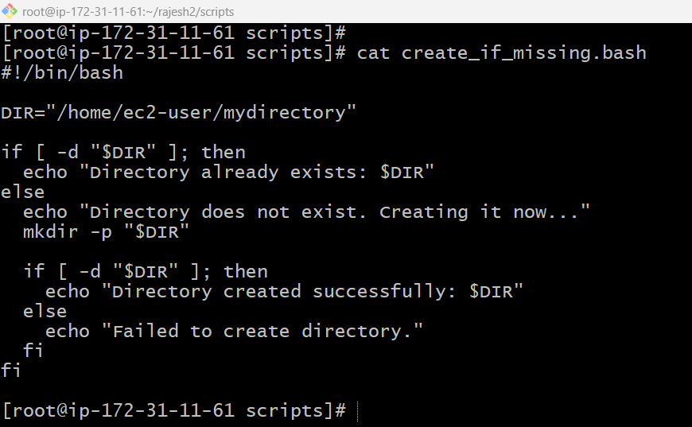

Step 2: Give it execute permission
chmod +x create_if_missing.bash
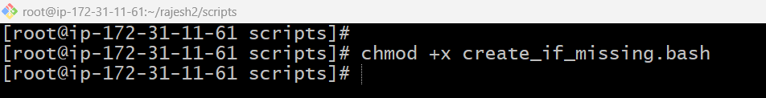

Step 3: Run the script
./create_if_missing.bash
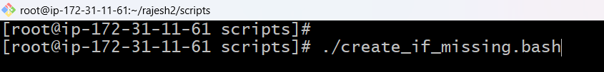

Step 4: Read the result

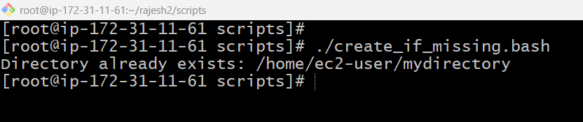
Quick Summary
1. Create file → 2. Write script → 3. chmod +x → 4. Run the script → 5. Check output (directory verified or created).
9. Create a bash script to delete the last 3 lines of a file.

Step 1: Create the script file
vim delete_last_lines.bash
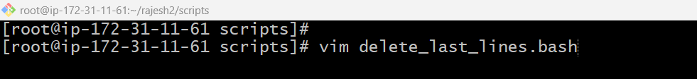

Press "I" + enter

#!/bin/bash

FILE="$1"

if [ -z "$FILE" ]; then
echo "Usage: $0 <filename>"
exit 1
fi

if [ ! -f "$FILE" ]; then
echo "File not found: $FILE"
exit 1
fi

LINES=$(wc -l < "$FILE")

if [ "$LINES" -le 3 ]; then
echo "File has 3 or fewer lines. Clearing file."
> "$FILE"
else
head -n -3 "$FILE" > "$FILE.tmp" && mv "$FILE.tmp" "$FILE"
echo "Last 3 lines removed from $FILE"
fi
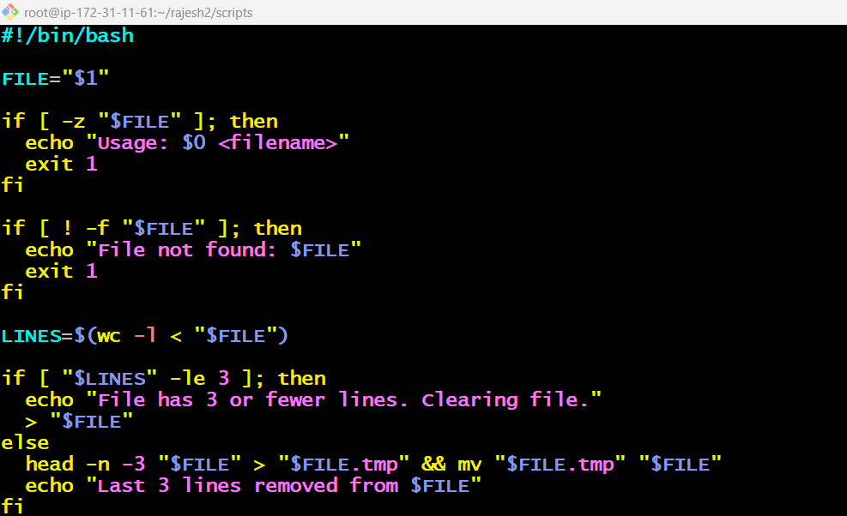

Save:
- Esc :wq Enter

Check the Information:
cat delete_last_lines.bash

Step 2: Give it execute permission
chmod +x delete_last_lines.bash
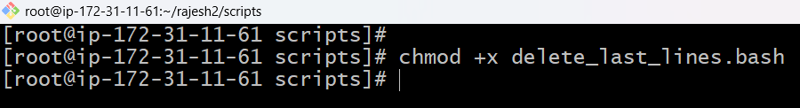

Step 3: Run the script
./delete_last_lines.bash sample.txt
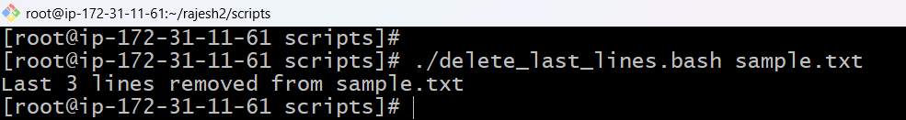

Step 4: Read the result

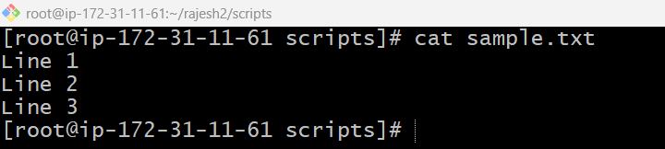
Quick Summary
1. Create file → 2. Write script → 3. chmod +x → 4. Run the script with a filename → 5. Check output (last 3 lines removed).
10. Create a bash script to monitor CPU usage and send an email notification if it exceeds 80%.

Step 1: Create the script file
vim cpu_monitor.bash
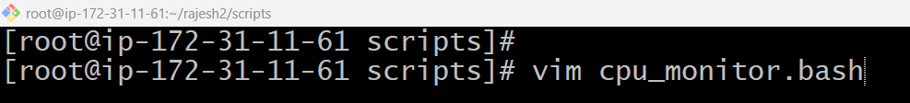

Press "I" + enter

#!/bin/bash

THRESHOLD=80
EMAIL="admin@example.com"

CPU_IDLE=$(top -bn1 | grep "Cpu(s)" | awk '{print $8}')
CPU_USAGE=$(echo "100 - $CPU_IDLE" | bc | cut -d. -f1)

echo "Current CPU usage: $CPU_USAGE%"

if [ "$CPU_USAGE" -gt "$THRESHOLD" ]; then
SUBJECT="High CPU Alert on $(hostname)"
BODY="Warning: CPU usage is at ${CPU_USAGE}%, which exceeds the ${THRESHOLD}% threshold."
echo "$BODY" | mail -s "$SUBJECT" "$EMAIL"
echo "Alert email sent to $EMAIL"
else
echo "CPU usage is normal. No alert sent."
fi
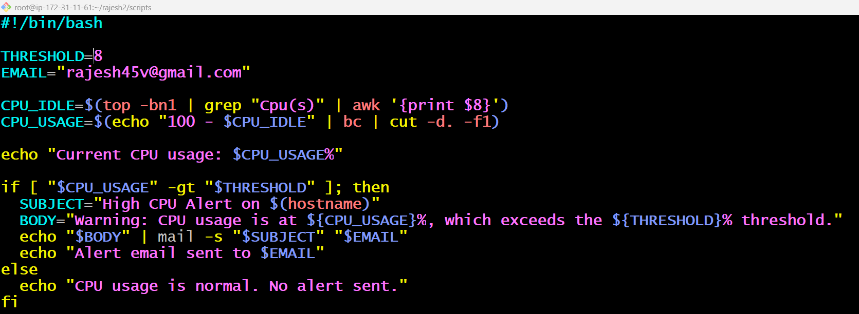

Save:
- Esc :wq Enter

Check the Information:
cat cpu_monitor.bash

Step 2: Give it execute permission
chmod +x cpu_monitor.bash
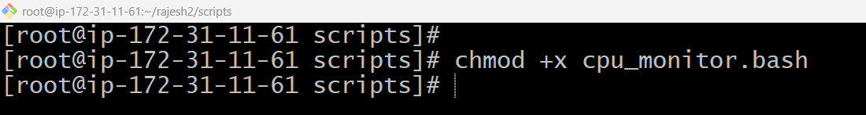

Step 3: Run the script
./cpu_monitor.bash
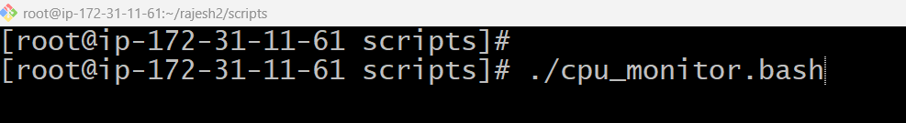

Step 4: Read the result
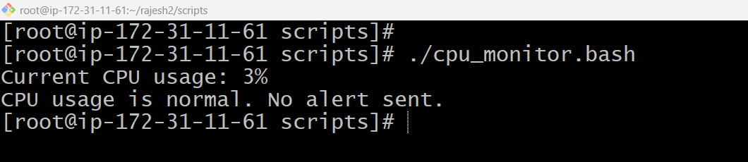
Quick Summary
1. Create file → 2. Write script → 3. chmod +x → 4. Run the script → 5. Check output (email sent if CPU > 80%).

11. Create a bash script to monitor disk space usage and send an email notification if it exceeds 80%.

Step 1: Create the script file
vim disk_monitor.bash
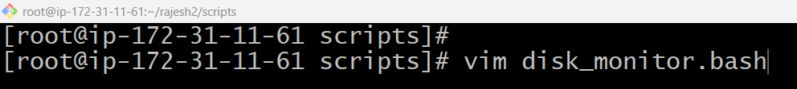

Press "I" + enter

#!/bin/bash
THRESHOLD=80
EMAIL="admin@example.com"

DISK_USAGE=$(df -h / | awk 'NR==2 {print $5}' | sed 's/%//')

echo "Current disk usage: $DISK_USAGE%"

if [ "$DISK_USAGE" -gt "$THRESHOLD" ]; then

SUBJECT="High Disk Usage Alert on $(hostname)"

BODY="Warning: Disk usage is at ${DISK_USAGE}%, which exceeds the ${THRESHOLD}% threshold."

echo "$BODY" | mail -s "$SUBJECT" "$EMAIL"

echo "Alert email sent to $EMAIL"

else

echo "Disk usage is normal. No alert sent."

fi

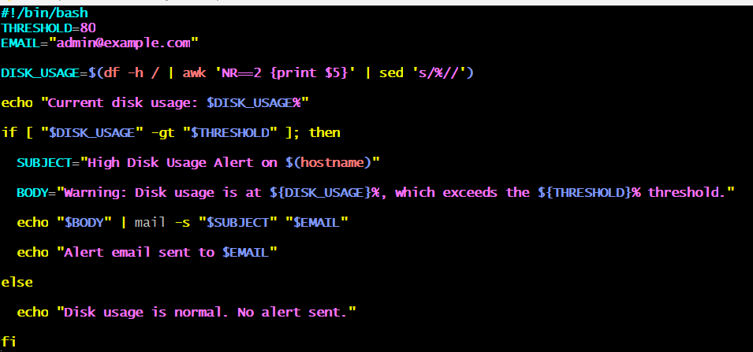
Save:
- Esc :wq Enter

Check the Information:
cat disk_monitor.bash

Step 2: Give it execute permission
chmod +x disk_monitor.bash
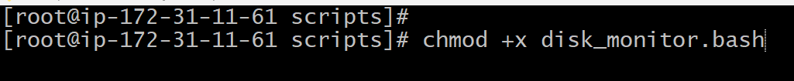
Step 3: Run the script
./disk_monitor.bash

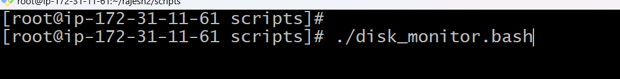

Step 4: Read the result

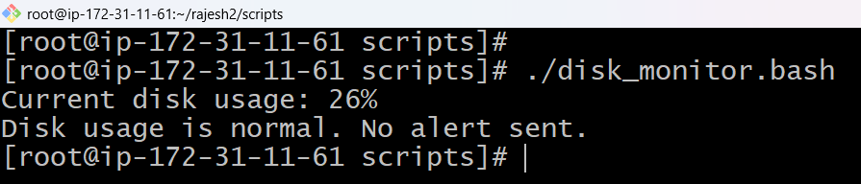

Quick Summary
1. Create file → 2. Write script → 3. chmod +x → 4. Run the script → 5. Check output (email sent if disk usage > 80%).
12. Create a bash script to monitor memory usage and send an email notification if it exceeds 80%.

Step 1: Create the script file
vim memory_monitor.bash
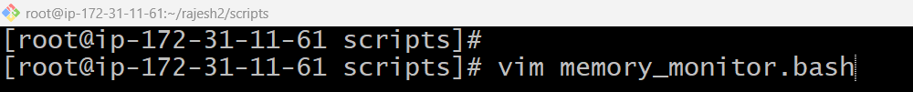

Press "I" + enter

#!/bin/bash
THRESHOLD=80
EMAIL="admin@example.com"

MEM_USAGE=$(free | awk '/Mem:/ {printf("%.0f", $3/$2 * 100)}')

echo "Current memory usage: $MEM_USAGE%"

if [ "$MEM_USAGE" -gt "$THRESHOLD" ]; then

SUBJECT="High Memory Usage Alert on $(hostname)"

BODY="Warning: Memory usage is at ${MEM_USAGE}%, which exceeds the ${THRESHOLD}% threshold."

echo "$BODY" | mail -s "$SUBJECT" "$EMAIL"

echo "Alert email sent to $EMAIL"

else

echo "Memory usage is normal. No alert sent."

fi
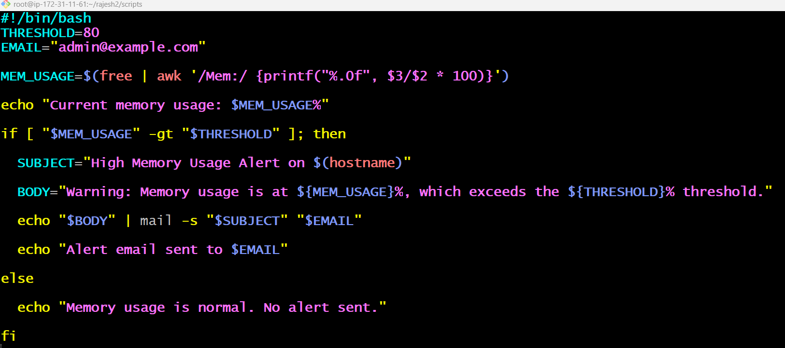

Save:
- Esc :wq Enter

Check the Information:
cat memory_monitor.bash

Step 2: Give it execute permission
chmod +x memory_monitor.bash
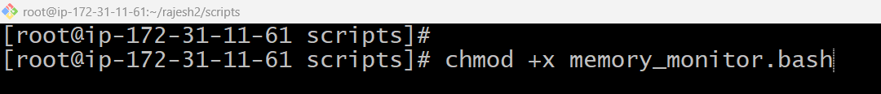

Step 3: Run the script
./memory_monitor.bash

Step 4: Read the result

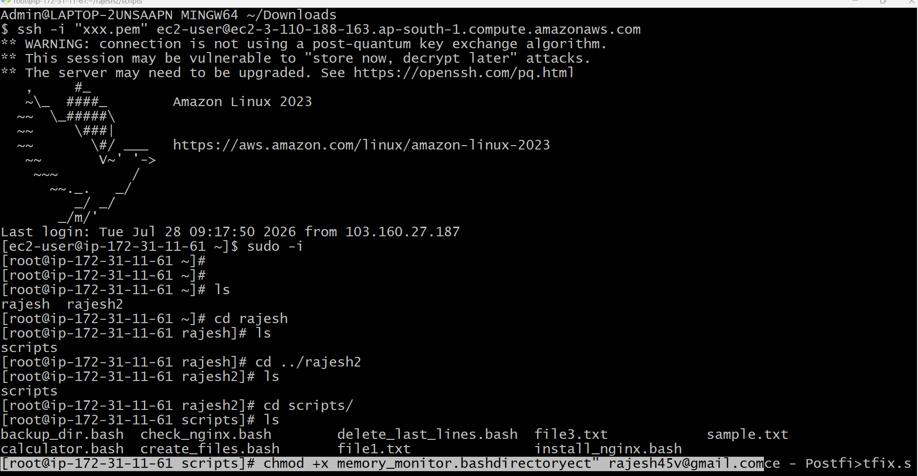

Quick Summary
1. Create file → 2. Write script → 3. chmod +x → 4. Run the script → 5. Check output (email sent if memory usage > 80%).

Crontab Entries
1. April 5th Midnight
Step 1: Create the script file
vim april_backup.bash
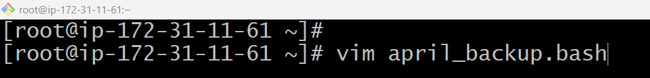

Press "I" + enter

#!/bin/bash

echo "Cron Job Executed Successfully on $(date)" >> /home/ec2-user/cron.log
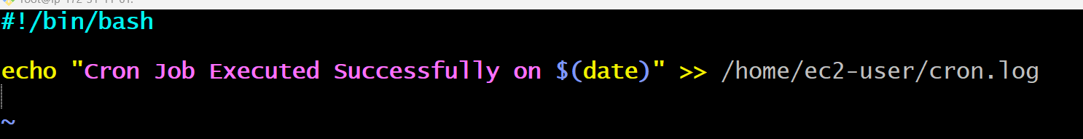

Save:
- Esc :wq Enter
Step 2: Check the script
cat memory_monitor.bash
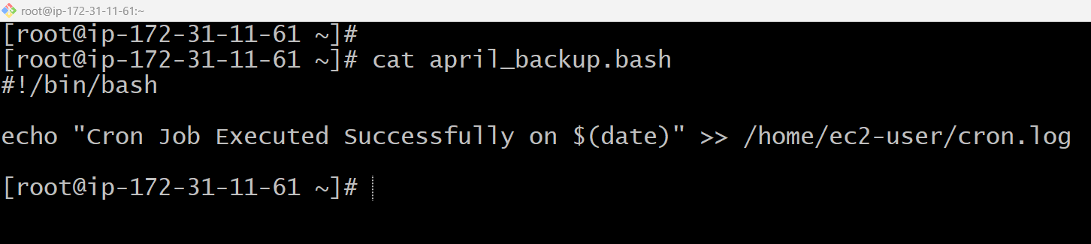

Step 3: Give execute permission
chmod +x april_backup.bash
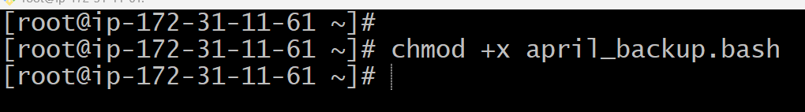
Step 4: Open Crontab
crontab -e
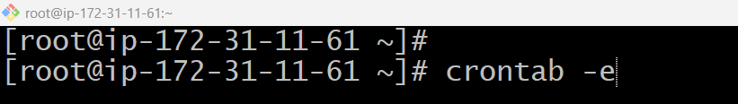
Add the following cron entry:
0 0 5 4 * /home/ec2-user/april_backup.sh
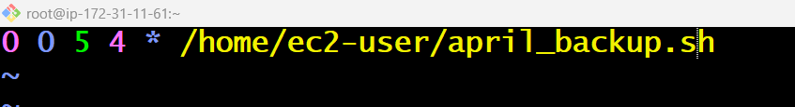
Save the file:
Esc :wq!

Step 5: Verify the cron job
crontab -l
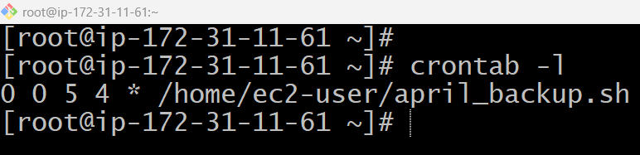
2. 5th of Every November, January, Juneif it is a Thursday
Step 1: Create the script file
vim thursday_check.sh

Press "I" + enter

#!/bin/bash

DAY=$(date +%u)

if [ "$DAY" -eq 4 ]
then
echo "Today is 5th and Thursday."
echo "Cron Job Executed Successfully on $(date)" >> /home/ec2-user/cron.log
else
echo "Today is not Thursday. Job skipped."
fi
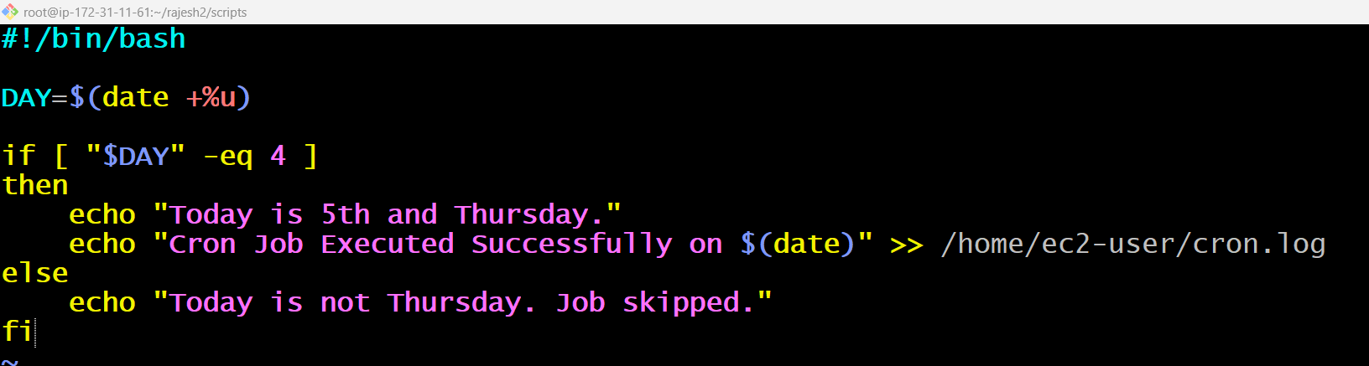

Save:
- Esc :wq Enter

Step 2: Give execute permission
chmod +x thursday_check.sh
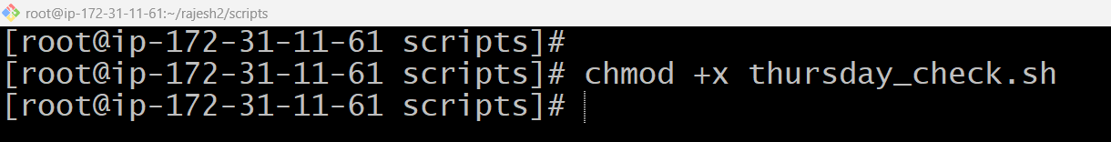

Step 3: Open Crontab
crontab -e
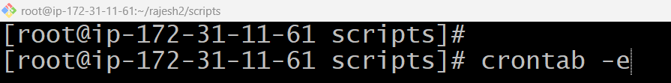
Add the following cron entry:
0 0 5 1,6,11 * /home/ec2-user/thursday_check.sh
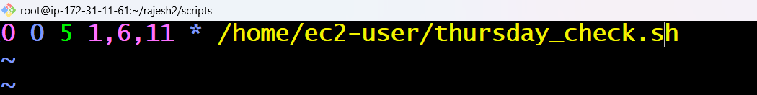
Save the file:
Esc :wq!

Step 5: Verify the cron job
crontab -l
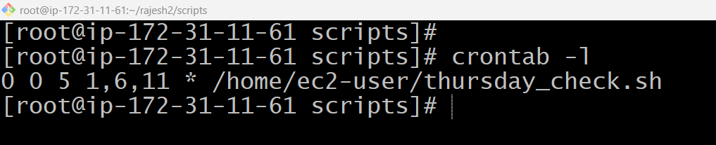

3. At05 and 27th minutesof9, 10, 11hours every day
Step 1: Create the script file
vim cron_time.sh
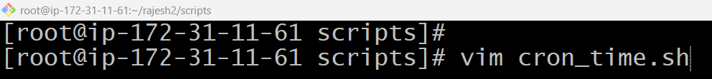

Press "I" + enter

#!/bin/bash

echo "Cron Job Executed Successfully on $(date)" >> /home/ec2-user/cron.log
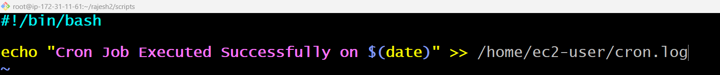

Save:
- Esc :wq Enter

Step 2: Give execute permission
chmod +x cron_time.sh
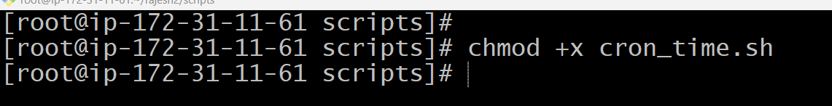

Step 3: Open Crontab
crontab -e
Add the following cron entry:
5,27 9-11 * * * /home/ec2-user/cron_time.sh
Save the file:
Esc :wq!

Step 5: Verify the cron job
crontab -l
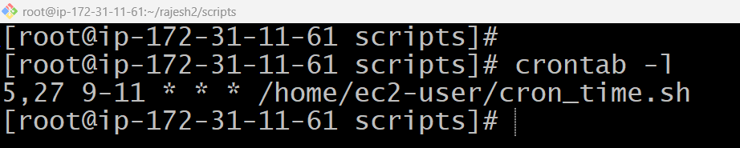

4. 34 minutesof9th houron15th August
Step 1: Create the script file
vim independence_day.sh
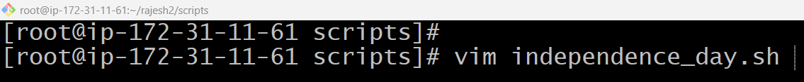

Press "I" + enter

#!/bin/bash

echo "Cron Job Executed Successfully on $(date)" >> /home/ec2-user/cron.log
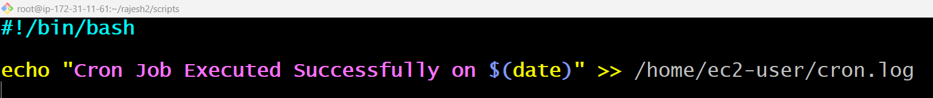

Save:
- Esc :wq Enter

Step 2: Give execute permission
chmod +x independence_day.sh
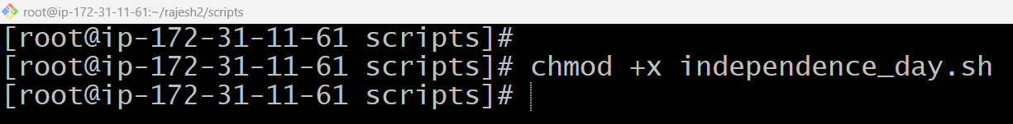

Step 3: Open Crontab
crontab -e
Add the following cron entry:
34 9 15 8 * /home/ec2-user/independence_day.sh
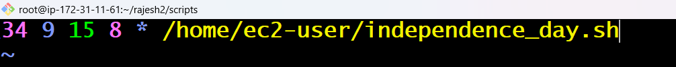
Save the file:
Esc :wq!

Step 5: Verify the cron job
crontab -l
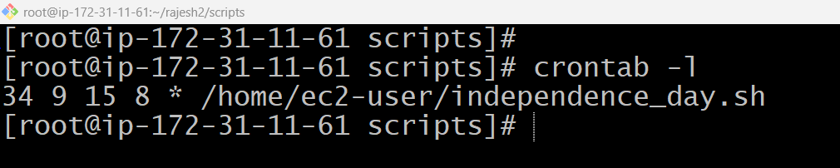
5. Every midnight
Step 1: Create the script file
vim midnight_job.sh
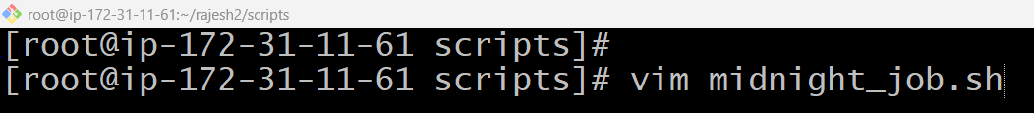

Press "I" + enter

#!/bin/bash

echo "Cron Job Executed Successfully on $(date)" >> /home/ec2-user/cron.log

Save:
- Esc :wq Enter

Step 2: Give execute permission
chmod +x midnight_job.sh
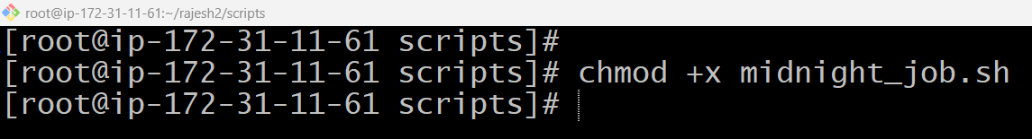

Step 3: Open Crontab
crontab -e
Add the following cron entry:
0 0 * * * /home/ec2-user/midnight_job.sh
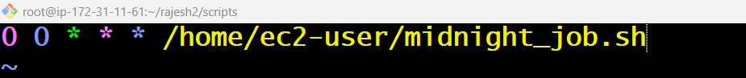
Save the file:
Esc :wq!

Step 5: Verify the cron job
crontab -l
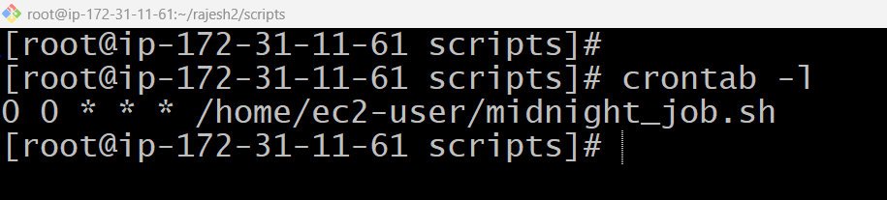

6. Every Weekend (Saturday night 11:59 PM)
Step 1: Create the script file
vim weekend_job.sh
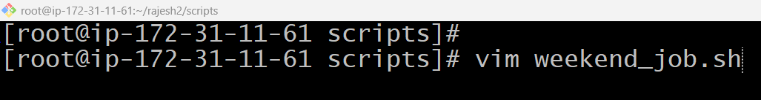

Press "I" + enter

#!/bin/bash

echo "Weekend Cron Job Executed Successfully on $(date)" >> /home/ec2-user/cron.log
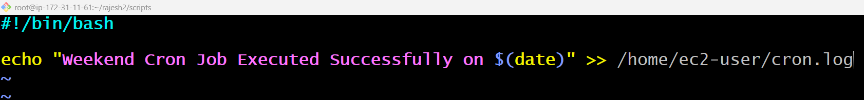

Save:
- Esc :wq Enter

Step 2: Give execute permission
chmod +x weekend_job.sh
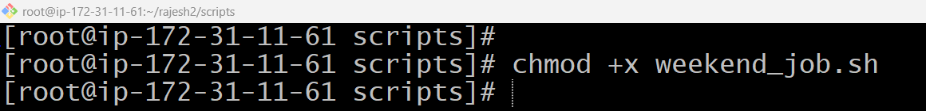
Step 3: Open Crontab
crontab -e
Add the following cron entry:
59 23 * * 6 /home/ec2-user/weekend_job.sh
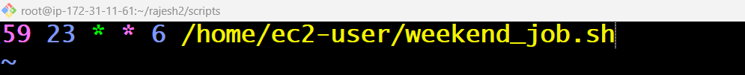
Save the file:
Esc :wq!
Step 5: Verify the cron job
crontab -l
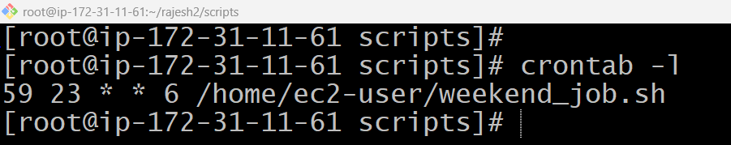
7. After every reboot
Step 1: Create the script file
vim startup_job.sh
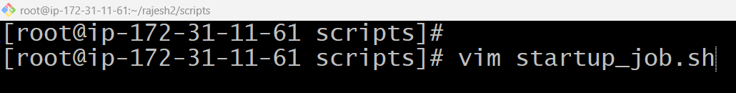

Press "I" + enter

#!/bin/bash

echo "System Rebooted Successfully on $(date)" >> /home/ec2-user/reboot.log
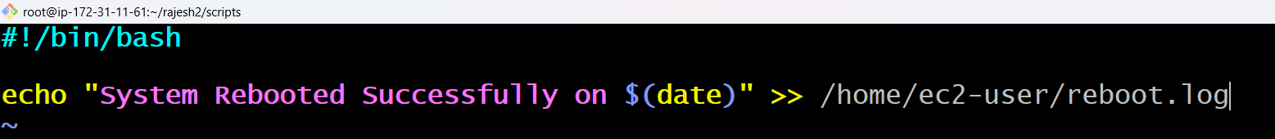

Save:
- Esc :wq Enter

Step 2: Give execute permission
chmod +x startup_job.sh
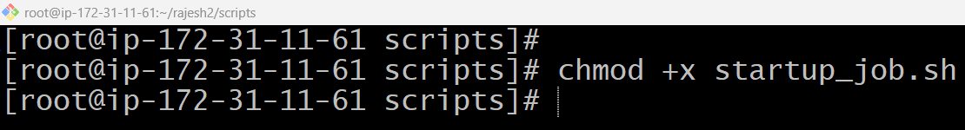
Step 3: Open Crontab
crontab -e
Add the following cron entry:
@reboot /home/ec2-user/startup_job.sh
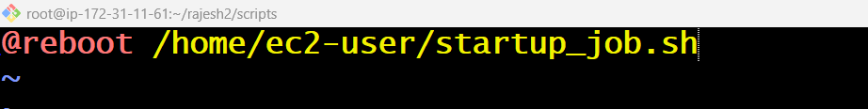
Save the file:
Esc :wq!
Step 5: Verify the cron job
crontab -l
